**ISAT 252—Analytical Methods IV**

**Programming and Problem Solving**

**Python Lab #9: Dictionaries**

**(25 points)**

**Due Date:** Friday April 10, 2015

**Objectives:**

* Create and use Python dictionaries to solve programming problems
* Know the differences between keys and values in dictionaries
* Be able to search dictionaries for key-values pairs.

**Deliverables:**

1. Soft copies of:
   1. Your working program and source code
   2. Your answers to the worksheet questions
2. Hard copies of:
   1. Your source code
   2. Your answer to the worksheet questions

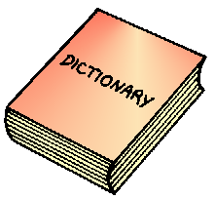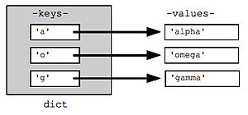

**ISAT 252—Analytical Methods IV—Programming and Problem Solving**

**Worksheet #9: Dictionaries (10 points)**

**True or False**

_T_The keys in a dictionary must be mutable objects.

_T_Dictionaries are not sequences.

_T_A tuple can be a dictionary key.

_T_A list can be a dictionary key.

_F_The dictionary method popitem does not raise an exception if it is called on an empty dictionary.

1. Write a statement that creates a dictionary containing the following key-value pairs:

'a' : 1

'b' : 2

'c' : 3

Values = {‘a’:’1’, ‘b’:’2’, ‘c’:’3’}

2. Write a statement that creates an empty dictionary.

Empty = {}

3. Assume the variable dct references a dictionary. Write an if statement that determines whether the key 'James' exists in the dictionary. If so, display the value that is associated with that key. If the key is not in the dictionary, display a message indicating so.

__author__ = 'kadar'  
dct = {'Ben':'1', 'Sean':'2', 'James':'3'}  
choice = input("Enter a name: ")  
**if** choice **in** dct:  
 print(dct.get[choice],"Not found")

4. Assume the variable dct references a dictionary. Write an if statement that determines whether the key 'Jim' exists in the dictionary. If so, delete 'Jim' and its associated value.

__author__ = 'kadar'  
dct = {'Jim':'Freshman', 'Sean':'Sophomore', 'Ben':'Junior', 'Keith':'Senior'}  
**if** 'Jim' **in** dct:  
 dct.pop('Jim')  
 print(dct)